Republic of Ireland do the double winning both the Snooker and the Pool Home International Tournaments
UCD Student Steven O’Reilly Captains both Irish teams to victory twice in 2 weeks.
Snooker
An extremely strong Irish Team – Steven O’Reilly (UCD, capt.), Johnny Williams (NUIM), Robert Donohoe (NUIM), Stephen Byrne (IT Tallagh), Conor Gaffney (IT Tallagh) and Paul Ennis (DIT) - were selected from the Intervarsity’s this year to represent their country at the Student Home Internationals Snooker on the 1st-2nd April in the Ivy Rooms Snooker Club in Carlow. Having finished runners-up for the past 3 years to England and having not won the tournament for 7 years, Ireland were determined to get their hands on the title albeit without the help of Vinny Muldoon (NUIM) who has played on the Professional Main Tour, as he was away at the Under 21 European Championships in Malta. Unfortunately, due to unforeseen circumstances, Scotland and Wales were not represented at the tournament. Alas, Ireland, England and Northern Ireland agreed to play each other twice to decide who would become champions in 2011.
Resounding results of 11-1 and 10-2 against Northern Ireland and 10-2, 9-3 wins over England gave Ireland the title with ease with England finishing runners-up with 2 wins out of 2 over Northern Ireland.
In the Individual Masters tournament the final was between UCD student Steven O’Reilly and former title holder Johnny Williams. In the first frame Johnny took an early lead with a 60 break but Steven fought back with breaks of 37 and 24 respectively only to snooker himself on the brown before giving the final chance of the frame to Johnny who cleared as expected. The second frame was again a close one, however, excellent potting from Williams ensured he took the title for the second time.
Highest break of the Weekend went to Johnny Williams of Ireland with an 86 break against England.
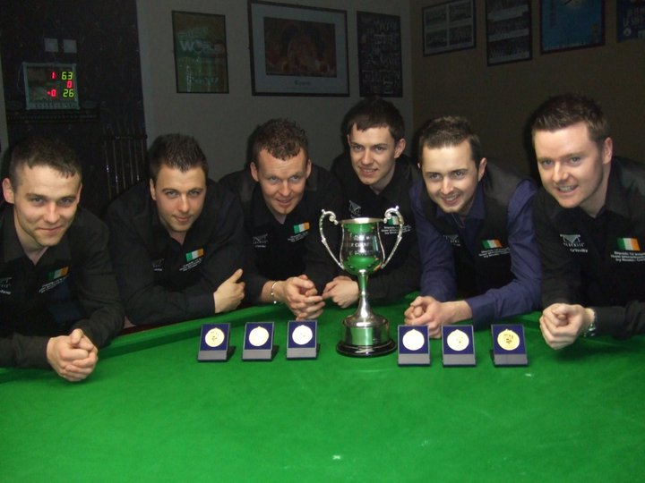
L-R: Robert Donohoe, Johhny Williams, Stephen Byrne, Conor Gaffney, Paul Ennis, Steven O’Reilly
Pool
An ever competitive Student Home International Pool Champioships was hosted by Northern Ireland this year in the Holiday Inn, Belfast on the 15th-16th April.
Here is a copy of the press release before the event and for more information visit http://www.upc-pool.org.uk/SHIs1011preview.htm

PRESS RELEASE

Team England searching for four-in-a-row in Belfast

The weekend of 15-16 April 2011 sees the culmination of the university pool season as the Student Eight-ball Pool Home Internationals descends on the Holiday Inn in Belfast with England Students the team to beat as they attempt to retain their title.
England will again start as the proverbial bookmaker’s favourites having, arguably, the strongest line-up in the competition on paper. They boast current BUCS-UPC Individual Champion Will Jerram, defending Individual Masters champion Tem Dixon, Welsh Blackball international Lee Morris, English World Rules International Jack Pople and experienced players in Michael Walsh, James Pettitt and Rhys Williams. The team will again be managed by the charismatic team manager, Jon Shapland, who will no doubt be instilling his annual reminder that despite the hype, pool events are not won on paper.
Although the England team is clearly expected to achieve, the other teams are also very competitive this season.
In a welcome return to the full complement of five nations competing, Northern Ireland will be keen to make the biggest impression on home soil. Their team will be built around the successful Queen’s Belfast side that won the HESPC Irish Intervarsities at the start of the season including key players such as Martin Quigg, Aedan McCotter and Gareth Quinn. With the addition of influential players such as Northern Ireland Under-21 international Conor McDonnell from University of Ulster, team manager Brian Keenan will have the belief that his side can ensure that the trophy will not be boarding a return flight to the mainland.
Ireland students will travel North of the border with a team sheet suggests they have a side capable of taking the title. Attention is first drawn to Stephen Dempsey who was the 2007 EEPF Men's European Champion and James McDonald who won the HESPC Irish Pool Intervarsities Individual Championship this season. Many other members of the team also featured prominently in this year’s Irish Championship such as Damian Farrelly and Michael Curley and they will be determined to wrest the trophy from England’s grasp.
Scotland Students, who so often feel their chances are written off before the play commences, will not be intending on flying to Northern Ireland to make up the numbers. The team is managed by former Scotland Student international Gary Ferguson and captained again by the evergreen Michael Rodgers. There is a good split of players between the three strong Scottish pool playing universities of Strathclyde, St Andrews and Robert Gordon and hopes will run high among the camp that they can go one better than their runner-up berth in 2009/10.
Huw Stapleton’s Wales Students side return this season with the bulk of the players coming from Cardiff University and bolstered by players from Glamorgan and Bangor. Many of the team played in the inaugural Welsh University Championships during the season and the invaluable experience gained will surely stand them in good stead for this season’s SHI event as they look to embellish some positive performances in this competition in prior years.
The event also features the Student International Masters. There will be no easy games in this individual event and it is interestingly the only occasion where players from Ireland Students meet their British counterparts. The eventual champion will certainly have earned their title battling through the elite field. The action gets underway with the Student International Masters at 1pm on Friday 15 April culminating in the final, expected to take place around 13h00 on Saturday 16 April. Team matches will start at 16h15 on Friday and the final will take place at 17h00 on Saturday.
8 April 2011
For further information and full results:
Dr. Iorwerth Griffiths
www.upc-pool.org.uk

Notes to editors:
The Universities Pool Council (UPC) is the governing body for pool at higher education level in the United Kingdom. It is recognised by the British Universities and Colleges Sport (BUCS), Scottish University Sport (SUS) and the English Pool Association (EPA).

The UPC organises national nine-ball, eight-ball and women’s eight-ball championships for teams and individuals. The UPC also organises the Student Home Internationals representative event.

Play began at 1 p.m. on the Friday afternoon with the Individual Masters Tournament. This was played until the round of the last 16 before the commencement of the main team event. Ireland first played Scotland and despite a few mistakes which led to a 6-5 score line, Ireland finished strong to win the tie 15-6. England followed suit, beating a very strong Northern Ireland team by the same score line, 15-6. The next match for Ireland was a crunch match against rivals England. This was to be a tester that would show both teams what the other had to offer and a lot of pride was at stake. As expected, it was a tight affair which eventually went all the way to 10-10. The final frame was between England’s James Pettitt and Irish Captain, Steven O’Reilly. After a few shaky misses on both parts, Steven was left with a tough red up the rail to the corner pocket. To Ireland’s delight, he fired it home and left him a shot on the final red before taking the black ball to the middle. Ireland 11-10. At the same time, Northern Ireland surprisingly lost out to the Welsh side in their first match of the tournament 8-13.
The day finished with the Individuals, which was played all the way to the final. Of the 8 Irish players to start the day in the individuals, 5 made it to the last 16 but only 1 made it past this round, Stephen Dempsey of NUIG. He eventually made it to the semi-final where he lost out 3-2 to the eventual winner Will Jerram of England.
The next day saw an early 9 a.m. start where Ireland faced Wales and England were up against Scotland. The score lines for the matches were 15-6 and 16-5 respectively. Ireland’s final match was against Northern Ireland. Perhaps the fact that they had qualified for the final, ‘the foot was taken off the gas’ so to speak, and they eventually won out the tie by the narrowest of margins, 11-10. Both Wales and Scotland still had it all to play for and the winner of this tie would have a great chance of making the final! As it turned out, the earlier impressive wales didn’t quite cut it and lost out by an 8-13 score line. The final round of matches meant Ireland had a bye; England hammered any hopes Wales had of making the final by defeating them 15-6. Scotland also had all hopes dashed after Northern Ireland clocked up their first win of the event with a convincing 13-8 win over the Scottish ensuring no team got the wooden spoon!
And so the group stage had finished in the order – Ireland, England, Northern Ireland, Wales and Scotland.
Ireland had ‘Home Advantage’ as they had topped the group and so had choice of who was to break-off first and they chose the option of breaking first, ensuring they had 11 of the 21 break-offs. Ireland took a much needed early lead of 3-0 before England tied at 3-3. Ireland again had a big push to go 7-3 in the lead before England clawed it back to 7-6. An uncharacteristic and pivotal blackball miss by English Captain Lee Morris left an excellent Darren Feehan in to take control of an all but lost frame which he eventually cleared to win and for Ireland to go 8-6 rather than 7-7. Ireland made it 10-6 and just needed 1 frame for the victory. The chance came to Conor O’Boyle who luckily found himself in the position of having a straight black to the middle for the frame, match and title. Indeed he pot the black and the celebrations from his fellow team mates began. However, it was all dashed in an instant when referee Mel Harley explained ‘the white ball had not stopped rolling when Conor put his cue on the table which subsequently hit a red ball on the table, therefore loss of frame’. To the Irish teams disgust, an immediate appeal followed but the decision was ruled final and the contest was still very much alive at 10-7 in Irelands favour. It looked like Ireland were to win again with Steven O’Reilly having a frame winning chance in the 18th frame. Unfortunately a very nervous miss left England’s Will Jerram in to take England to trail by just 2 frames, 10-8. The spectators couldn’t believe when England won yet another frame to take it to 10-9. Surely Ireland couldn’t lose after essentially winning the tournament but for a technicality! To Ireland’s delight and moreover, relief, Intervarsity individual champion James McDonald stepped up to the mark and broke off in the 20th frame and went on to make a fantastic clearance, potting some very difficult balls, while ensuring once the black had fallen that everything on the table had come to a halt and the referee had called frame and match. Ireland 11 England 9, Ireland win the title of Student Home International Pool Champions. Ireland and NCI Student Damien Farrelly also won the title of MVP (most valuable player) winning 12 out of 12 frames for the weekend which is a record that no one has ever achieved before.
For more results and information go to http://www.upc-pool.org.uk/SHIs201011review.htm

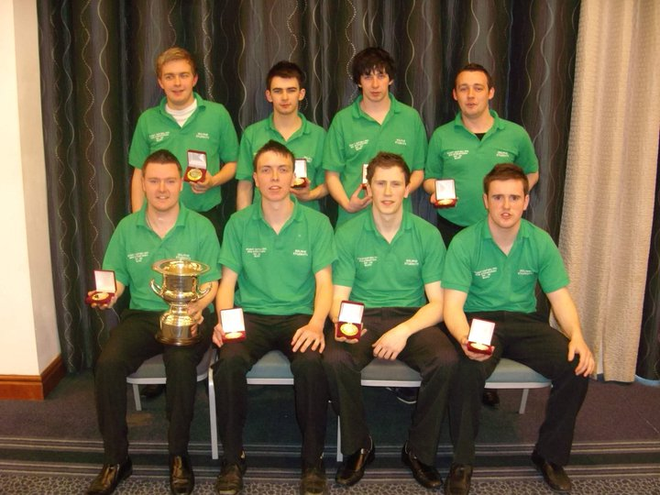

Back row (L to R): Conor O’Boyle (DCU), David Moore (DCU), Damien Farrelly (NCI), Darren Feehan (ICD)
Front row (L to R): Steven O’Reilly (capt., UCD), Micheal Curley, (UCD), James McDonald (DIT), Stephen Dempsey (NUIG)

